**EVENT MANAGEMENT SYSTEM**

**EvenTrack**

List of similar products

|  |  |  |
| --- | --- | --- |
| Product name | features | url |
| Eventbrite | Event creation, ticketing, attendee management, analytics, mobile check-in, email campaigns | https://www.eventbrite.com |

Name : ARUNAGIRINATHAN

Official email id : [927623BAD008@mkce.ac.in](mailto:927623BAD008@mkce.ac.in)

Personal email id : arun31.march.2k6@gmail.com

Phone No: 9363624344

**CONTRIBUTION : TABLE NORMALIZATION,FOM DESIGN,CONNECTING TO THE DATABASE**

**REPORTS,SCHEMA DESIGN**

Sites.google.com:

Portfolio:

Git hub: https://github.com/ARUNAGIRINATHAN-K

Leet code:

**Tables Name:**

User(Master Table)

* user_id (Primary Key)
* name
* email
* password

Event(Transaction Table)

* event_id(Primary Key)
* title
* description
* date

Ticket (Transaction Table)

* Ticket_id (PK)
* user_id (FK → users.user_id)
* event_id (FK → events.event_id)

**Report Generation Table:**

Event name  
Event id

Participation list

create table User;

insert table user:

Keywords:

Relation: User

Attribute: email.id

Domain:

Tuple

Database Normalization:(1NF,2NF,3NF,4NF,5NF)

**1NF**

User - My table in 1NF because it has a primary key

**2NF**

My table in 2NF because it has a primary key – event_id and All other columns are dependent in the primary key.

**3NF**

Keywords-should be in 2NF no transitive partial dependencies.

**Example :**

Student_id : 927623bad008

Name : ARUNAGIRINATHAN K

Job_id : j_018

Job_name : Software Engineers

State_id : 08

State_name : Madurai

1NF – student_id & Name

2NF - Student_id,Job_id

Student_info – name_id,name,state_id & state_name

Job – Job_id & Job_name

3NF – Student _role table & Student_info table

Student_id,Student_name & State_id

Job_id,Job_name,State_id & state_name

Frontend – phpMyAdmin(5.2.2), html,css ,js ,react.js,tailwind.css, flask, Android , Flutter

Backend – MySQL,oracle,MangoDB,Json,SQLlite , Firebase

Server – Xampp (V3.3.3)

Editor – VS code

Frame work – Node.js,

Language- Python

Example:

* User(Parent tag)

Column : user_id,Name,email,password

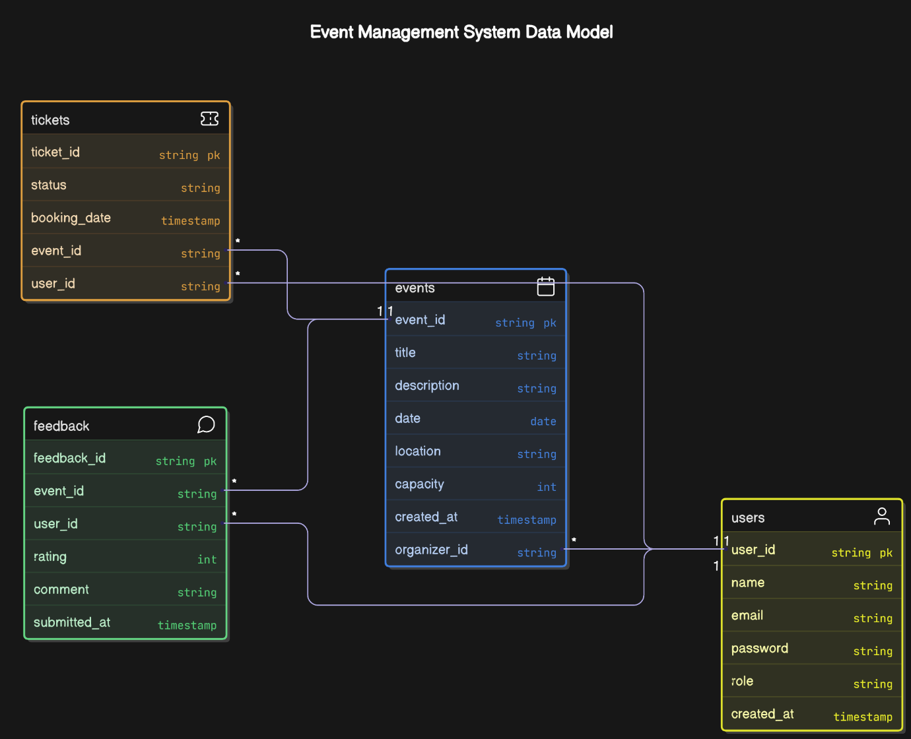

DTD with no elements

XML

<Login>Timeout =100</login>

DTD

<ELEMENT LOGIN EMPTY >

<!ATTLIST TIMEOUT>

JOIN operation

INNER JOIN.

SELECT

users.name,

users.email,

tickets.booking_date

FROM

tickets

JOIN

users ON tickets.user_id = users.user_id

WHERE

tickets.event_id = 5;

**modules details**

|  |  |  |
| --- | --- | --- |
| Module name | Sub module detail | description |
| User Management | User Registration | |  | | --- | | Allows users to sign up as Admin, Organizer, or Attendee. |  |  |  |  | | --- | --- | --- | |  |  |  |  |  |  |  | | --- | --- | --- | |  |  |  | |
| |  | | --- | |  |  |  | | --- | | Login & Authentication | | Secure login system with password validation and session handling. |
| |  | | --- | |  |  |  | | --- | | Role-Based Access | | Controls access to features based on user roles (Admin, Organizer, Attendee). |

|  |  |  |  |  |
| --- | --- | --- | --- | --- |
| MODULE NAME/SUB MODULE NAME | FORM NAME-TYPE | FORM DESCRIPTION | TABLE NAME- TYPE | TABLE DESCRIPTION |
| Create Event | Event Form | Form for organizers to create new events with full details | events - Transaction | Stores event details like title, date, capacity, location, organizer. |